GRAPHICS WITH CITATIONS
Organize the Future · Claim the Future

The Heat Came First. Texas Can See What's Next.
RB Sydney, MS · Organize the Future · August 2026 · Tier 2 Regional · Where Partisans Agree Lane
Citation style: Chicago Author-Date throughout. · Built: 2026-08-31
Each graphic is cited with the same rigor as a textual claim.
The images in this document are the same size as the web version and can be copied and pasted readily. Each graphic also has a full URL to download both the web and the larger print versions.
Description | NWS Houston/Galveston maximum heat index graphic for Sunday, Aug. 16, 2026, showing a regional maximum of 108°F. Placed following the heat index table.
Citation | National Weather Service Houston/Galveston. 2026. "Maximum Heat Index, August 16, 2026." NOAA National Weather Service.
Source Type | Government operational product — NWS Weather Forecast Office HGX
Tier | 2 — Operational
URL | https://www.weather.gov/hgx

Graphic 1 — NWS Houston/Galveston Maximum Heat Index, Aug. 16, 2026

URLs to download both the web and the larger print versions.
https://organizethefuture.org/packages/Extreme_weather/Graphics/RBSYDNEY_Aug_TXHeat_26_HGXHtIdx_print.png
https://organizethefuture.org/packages/Extreme_weather/Graphics/RBSYDNEY_Aug_TXHeat_26_HGXHtIdx_web.png
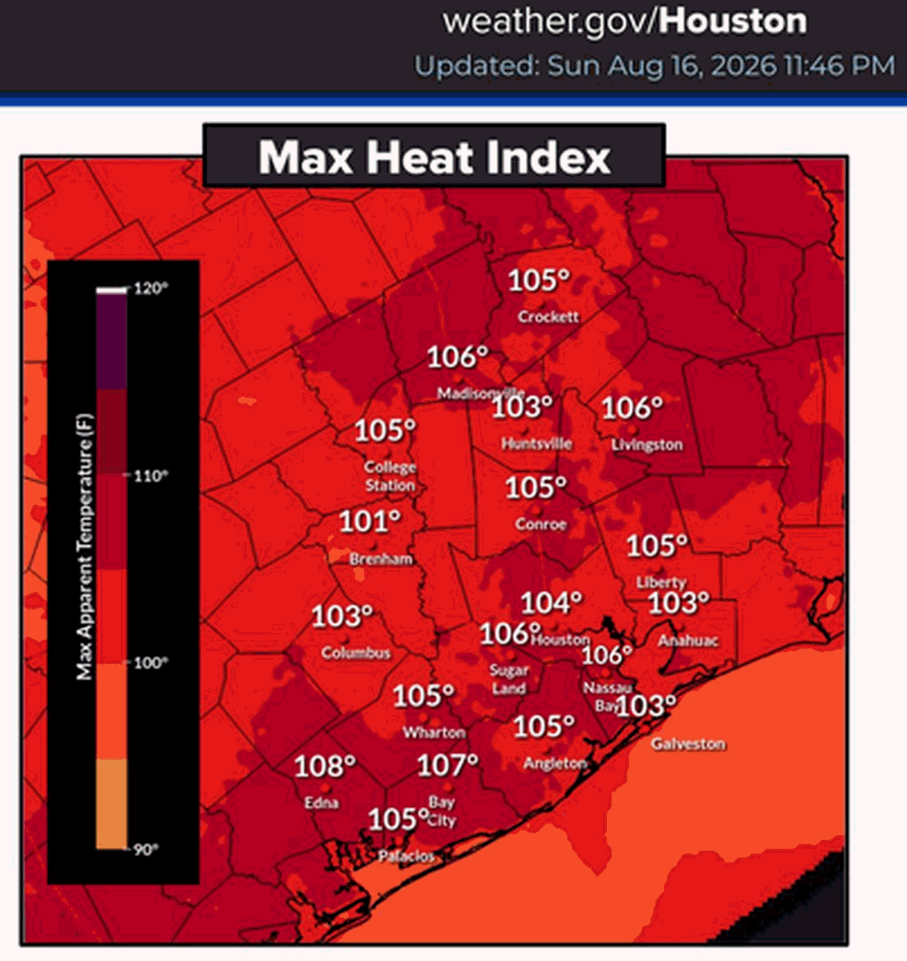
Description | Weekly drought statistics table for Texas showing coverage by category D0 through D4, valid Aug. 25, 2026. Supports the 90% coverage and DSCI 183 figures.
Citation | National Drought Mitigation Center, US Department of Agriculture, and National Oceanic and Atmospheric Administration. 2026. "US Drought Monitor — Texas Statistics, August 25, 2026." Valid August 25, 2026.
Source Type | Government dataset — US Drought Monitor
Tier | 1
URL | https://droughtmonitor.unl.edu/DmData/DataTables.aspx
Archive | https://droughtmonitor.unl.edu/Maps/MapArchive.aspx

Graphic 2 — US Drought Monitor Texas statistics, Aug. 25, 2026

URLs to download both the web and the larger print versions.
https://organizethefuture.org/packages/Extreme_weather/Graphics/RBSYDNEY_Aug_TXHeat_26_DrtTbl_print.png
https://organizethefuture.org/packages/Extreme_weather/Graphics/RBSYDNEY_Aug_TXHeat_26_DrtTbl_web.png
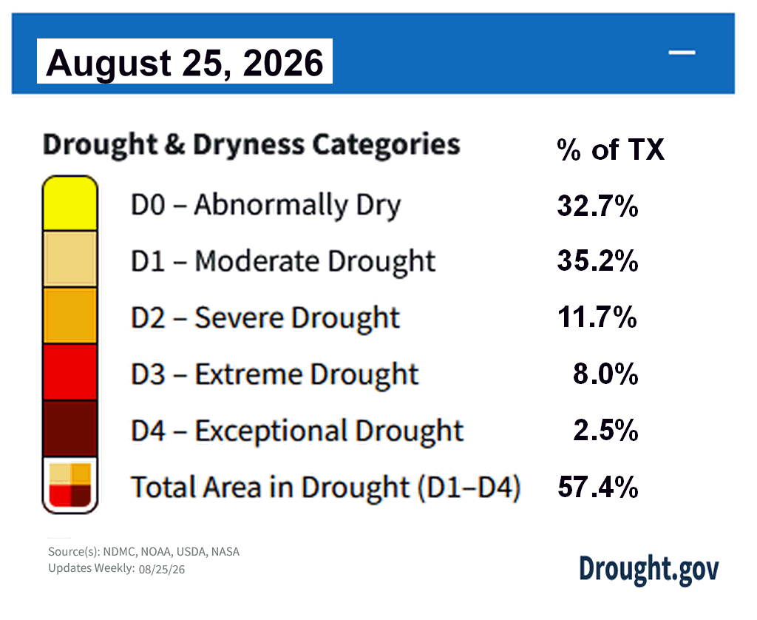
Description | US Drought Monitor map of Texas, valid Aug. 25, 2026, showing the geographic distribution of drought categories referenced in the accompanying table.
Citation | National Drought Mitigation Center, US Department of Agriculture, and National Oceanic and Atmospheric Administration. 2026. "US Drought Monitor — Texas, August 25, 2026." Valid August 25, 2026.
Source Type | Government dataset — US Drought Monitor
Tier | 1
URL | https://droughtmonitor.unl.edu/Maps/MapArchive.aspx

Graphic 3 — US Drought Monitor Texas map, Aug. 25, 2026

URLs to download both the web and the larger print versions.
https://organizethefuture.org/packages/Extreme_weather/Graphics/RBSYDNEY_Aug_TXHeat_26_DrtMap_print.png
https://organizethefuture.org/packages/Extreme_weather/Graphics/RBSYDNEY_Aug_TXHeat_26_DrtMap_web.png
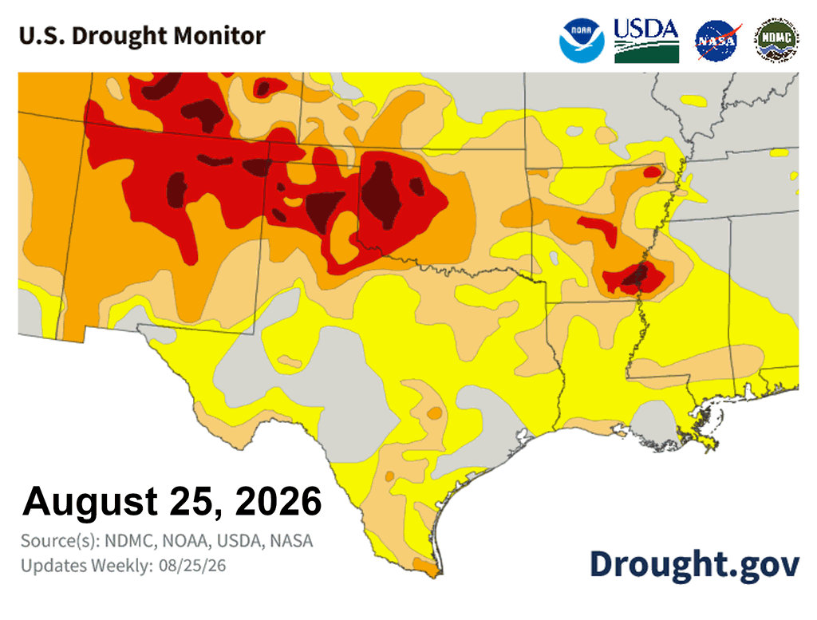
Graphic 4 — NOAA CPC Rapid Onset Drought outlook, Aug. 25, 2026
Description | NOAA Climate Prediction Center map showing Rapid Onset Drought risk areas covering Texas, dated Aug. 25, 2026. Supports the D0 transition figure and the mid-September risk statement.
Citation | NOAA Climate Prediction Center. 2026. "US Hazards Outlook, Days 8–14 — Rapid Onset Drought, August 25, 2026."
Source Type | Government operational forecast product — NOAA CPC
Tier | 2 — Operational
URL | https://www.cpc.ncep.noaa.gov/products/predictions/threats/threats.php
URLs to download both the web and the larger print versions.
https://organizethefuture.org/packages/Extreme_weather/Graphics/RBSYDNEY_Aug_TXHeat_26_CPCDrtMap_print.png
https://organizethefuture.org/packages/Extreme_weather/Graphics/RBSYDNEY_Aug_TXHeat_26_CPCDrtMap_web.png
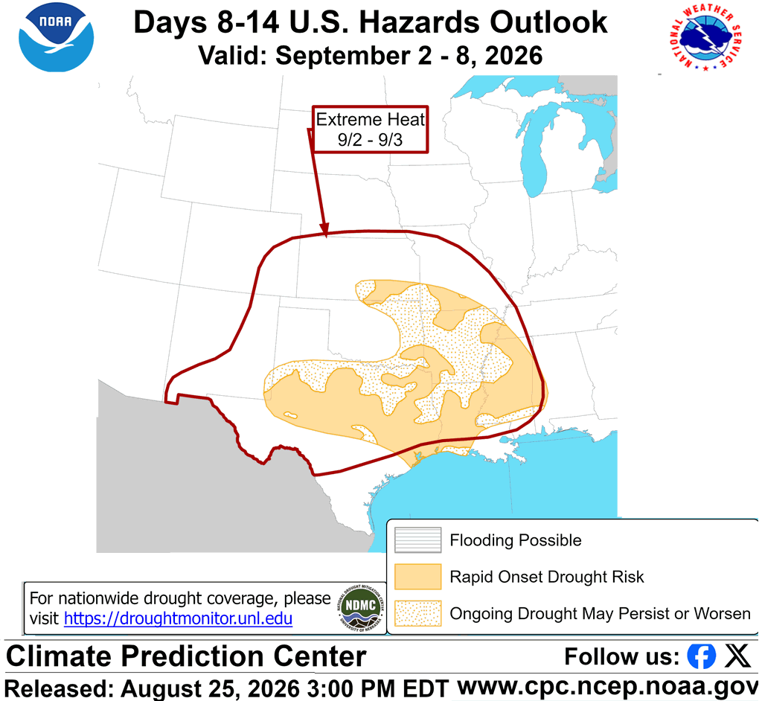

Editorial Contact: Editor@organizethefuture.org
Organize the Future — a solutions-based civic publication · August 2026

