The Heat Came First. Texas Can See What's Next.

You don't have to agree on why — to agree on what.
By RB Sydney · Science Writer and Analyst, Northern California · Sept. 2026

Extreme Heat Warnings across Texas — is this recent heatwave a business-as-usual condition or something more extreme? What the warnings do mean is conditions were above the threshold that puts people in real danger. That makes this a life-or-death situation.

It seems counterproductive that weather has turned into a political issue with all sorts of divisive ideas and abuse about our views. Another option is working together and adapting to the measured results. That is important as this could go on for a long time or change within a few days — as it already did. Adapting with resilience is a way to manage our lives better without taking any of it personally. Weather just is.

Typical or extreme
The basic temperature data from automated weather stations is clear but it is less obvious whether that temperature is typical or extreme at any time of year or location.
That is where the 30-year daily temperature running averages come into play. Simply averaging daily numbers from the nearest weather stations over 30 years makes a math statement of how many degrees the current temperature is above or below normal.
The National Weather Service (NWS) and Apple Weather showed 3 to 5 degrees above average for three Texas cities in the second week of August. By Aug. 23 and 24, Apple Weather data showed Austin and Houston above the 30-year average daily maximum by 7 to 8 degrees and Dallas by 10 to 11 degrees — roughly double the earlier readings, with Dallas at 105 and 106 degrees.
Temperature is only one measurement a smartphone feed like Apple Weather carries. Another is humidity, measured as dew point, which drives the Heat Index.
When does 93 equal 108? When the dew point is in the 60s and 70s that correlates to discomfort and distress and relates to a higher Heat Index as it did on Friday, Aug. 14.
City | Daily high | NWS heat index | Alert status
Houston | 93°F | 102–112 | NWS Houston/Galveston hazard message
Austin | 97°F | up to 109 | Point forecast

Here is what Houston looked like the Sunday, Aug. 16, two days later.
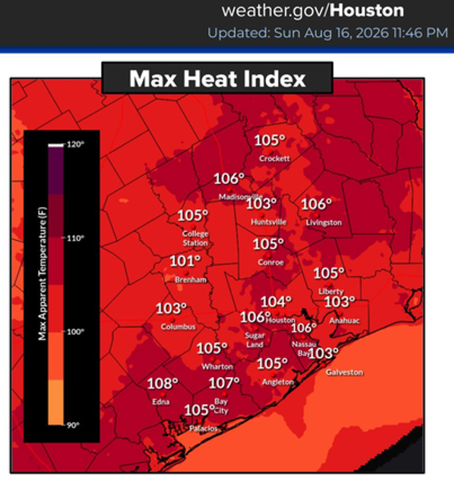
By the end of the third week the NWS temperature in Austin was at 105 degrees and Houston was at 100 degrees with correspondingly higher heat indexes. That is how Heat Indexes move into the Extreme Heat Warning territory when the impacts on all living things turn serious.
There is a NOAA Climate Prediction Center (CPC) prediction that the combined heat and humidity will last two more weeks going into September. Every high-risk day in a row increases the risk of heat stroke or worse.

Where this goes
One part of this does not add up. Houston and Austin showed high humidity with little chance of rain. The moisture must be coming from somewhere else. Earth.nullschool.net shows a tropical air mass pushing hot, humid surface air up from the Gulf and northern Mexico. Tropical air usually brings rain. There is almost none in that picture.
The website Drought.gov shows that central Texas is in a widespread drought. The drought is not coming. It is here.
Drought.gov showed Texas on Aug. 11 with 27.9% of Texas in mostly moderate drought and just under another 30% being “Abnormally Dry.” Two weeks later the following table for Aug. 25 shows drought had spread with increased intensity.
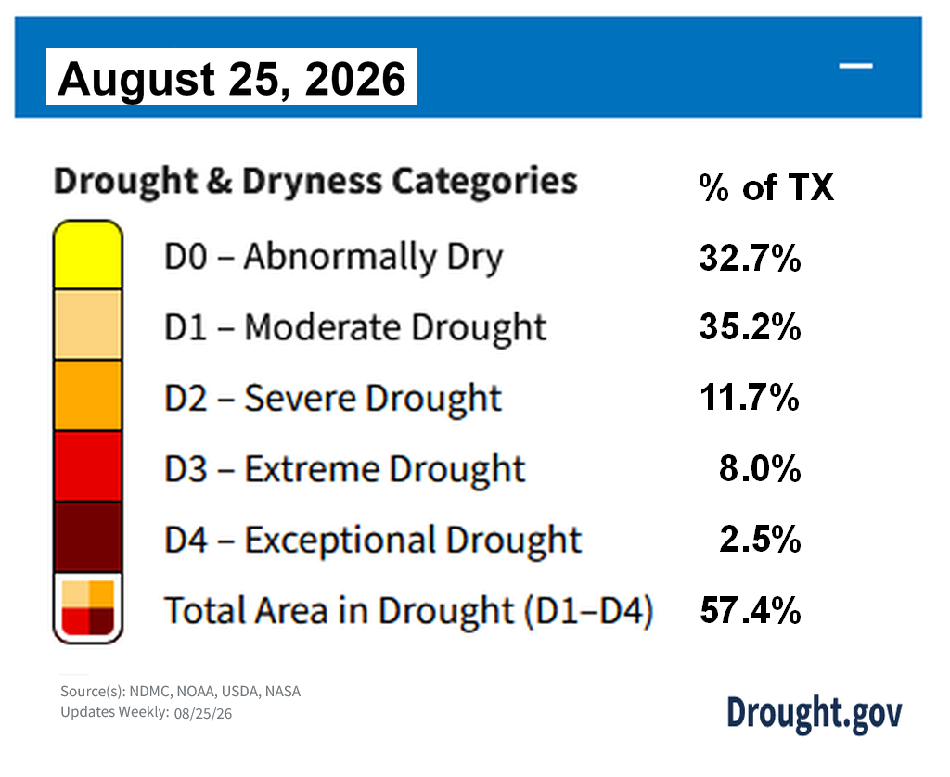
The map connected to this table showed this happening over a large area.
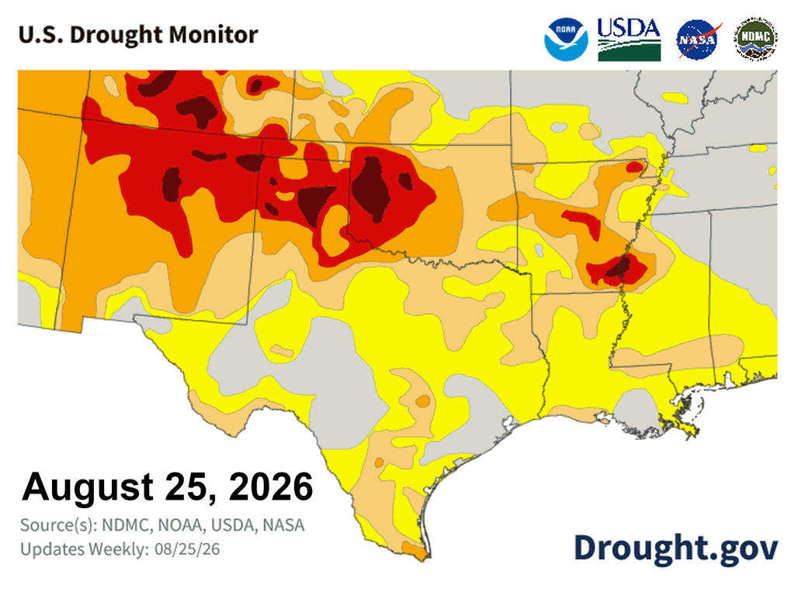
The NOAA CPC table for Aug. 25 shows most of the recent Abnormally Dry areas (“D0” at over 33% of the state) succumbing to the Rapid Onset Drought.
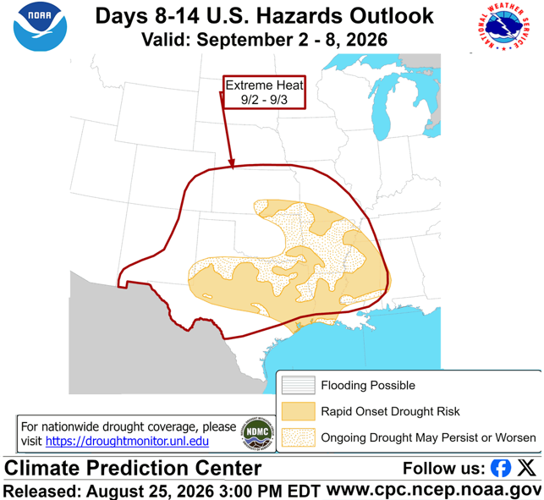
The Texas drought this year goes back to the unseasonable heat wave in March when 98.8% of the state was abnormally dry or in drought with a Drought Severity and Coverage Index of 285 (DSCI — possible values from 0 to 500). In less than four months on July 31, the covered area was below 40% and the DSCI at 72, which would have sounded really good.
Just over three weeks later, on Aug. 25, the coverage was up at 90% again with a DSCI of 183. That describes a Rapid Onset Drought as predicted by the CPC with a high risk of more into mid-September.

Weather as usual!
The arrival of Tropical Storm/Depression Edouard in Houston with potential flooding may forestall the drought development. Then there is El Niño. That adds even more unpredictability to the situation. This looks more like a wild rodeo ride than weather as usual.
This shared chaos is hitting people with a reputation for being tough and knowing how to work together. Having been to every state, if anyplace can handle and adapt to this it would be Texas. This crazy extreme weather is something to look square in the eye, set aside your differences and get everyone, especially your elected officials, to do what needs to be done.

Author's Note and US-06 series description.
Author's Note to Editor — do not publish
Classification. Several terms are formal designations and are capitalized intentionally: Extreme Heat Warning (a National Weather Service product, renamed from Excessive Heat Warning in March 2025), Heat Index, Rapid Onset Drought, Abnormally Dry (D0), and Drought Severity and Coverage Index (DSCI). Please preserve capitalization as written.
Apparent temperature. The piece uses Heat Index throughout and avoids "Feels Like," which is a vendor display label with no single standard behind it. NWS uses Heat Index and apparent temperature interchangeably in its own products. Please do not substitute.
Heat index figures. The 93 is Houston's daily high on Aug. 14. The 108 is the regional maximum on the NWS Houston/Galveston Max Heat Index graphic for Aug. 16, included with this piece. Both fall within the same NWS forecast area. They are separate readings from separate products, presented as such, not a point-matched pair.
Heat index sourcing. Heat index values in the table are NWS-issued figures from published advisories and point forecasts, not calculated from the daily high temperatures shown alongside them.
Observational data. Daily high figures in the table and the Austin, Houston and Dallas readings in the text are observational field data from Apple Weather (WeatherKit), which distributes NWS/NOAA and Weather Company reports, cross-checked against weather.gov. Standard op-ed convention for real-time readings.
Perishable figures. Drought coverage and DSCI values are current as of Aug. 25, 2026, and will change with the next Drought Monitor release. They are presented as time-stamped readings, not settled totals.

The series description
This piece is part of a developing four-stage civic framework — Organize the Future · Claim the Future — that moves from documented reality through civic obligation and common ground to practical action, using facts, reason, and the principles of nonviolent communication.
Where Partisans Agree is the framework's third stage. Each piece identifies where evidence points the same direction from both sides of a political divide, and builds the argument from that shared ground. When a piece names an adversary it names a behavior, never a party or a person, and the closing frames action as agreement rather than compromise.
Author Bios and Headshot
 RB Sydney

Basic Bio (75 words) — Tier 2
RB Sydney is a science writer and analyst in Northern California. He holds an M.S. in International Agricultural Development from UC Davis and a B.A. in Biological Science, and has tracked bio-regional conditions across North America since 1972. His analytical work has been published by the California Governor's Office and by nonprofit publications including the North Coast Environmental Center. He wrote "History of the Farmers Markets" and has spent decades on drought and extreme weather in the field.
Byline Bio (23 words)
A science writer and analyst with an M.S. in International Agricultural Development from UC Davis, and author of "History of the Farmers Markets."

Rights and Usage Statement
Organize the Future · Claim the Future Standard rights and usage language for op-ed distribution are available in two variants — Simultaneous / Non-Exclusive is typical and Exclusive (First Serial) Offering is possible upon request.

Unformatted text only
The Heat Came First. Texas Can See What's Next.
You don't have to agree on why — to agree on what.
Extreme Heat Warnings across Texas — is this heatwave a business-as-usual condition or something more extreme? What the warnings do mean is conditions are above the threshold that puts people in real danger. That makes this a life-or-death situation.
It seems counterproductive that people have turned weather into a political issue with all sorts of divisive ideas and desires to abuse each other about our views. Another option is working together and adapting to the measured results. That is important as this could go on for a long time or change within a few days. Adapting with resilience is a way to manage our lives better without taking any of it personally. Weather just is.
Typical or extreme
The basic temperature data from automated weather stations is clear but it is less obvious whether that temperature is typical or extreme at any time of year or location.
That is where the 30-year daily temperature running averages come into play. Simply averaging daily numbers from the nearest weather stations over 30 years makes a math statement of how many degrees the current temperature is above or below normal.
The National Weather Service (NWS) and Apple Weather showed 3 to 5 degrees above average for three Texas cities in the second week of August. By Aug. 23 and 24, Apple Weather data showed Austin and Houston above the 30-year average daily maximum by 7 to 8 degrees and Dallas by 10 to 11 degrees — roughly double the earlier readings, with Dallas at 105 and 106 degrees.
Temperature is only one measurement a smartphone feed like Apple Weather carries. Another is humidity, measured as dew point, which drives the Heat Index.
When does 93 equal 108? When the dew point is in the 60s and 70s that correlates to discomfort and distress and relates to a higher Heat Index as it did on Friday, Aug. 14.
City Daily high NWS heat index Alert status
Houston 93°F 102–112 NWS Houston/Galveston hazard message
Austin 97°F up to 109 Point forecast

Here is what Houston looked like the Sunday, Aug. 16, two days later.

By the end of the third week the NWS temperature in Austin was at 105 degrees and Houston was at 100 degrees with correspondingly higher heat indexes. That is how Heat Indexes move into the Extreme Heat Warning territory when the impacts on all living things turn serious.
There is a NOAA Climate Prediction Center (CPC) prediction that the combined heat and humidity will last two more weeks going into September. Every high-risk day in a row increases the risk of heat stroke or worse.
Where this goes
One part of this does not add up. Houston and Austin showed high humidity with little chance of rain. The moisture must be coming from somewhere else. Earth.nullschool.net shows a tropical air mass pushing hot, humid surface air up from the Gulf and northern Mexico. Tropical air usually brings rain. There is almost none in that picture.
The website Drought.gov shows that central Texas is in a widespread drought. The drought is not coming. It is here.
Drought.gov showed Texas on Aug. 11 with 27.9% of Texas in mostly moderate drought and just under another 30% being “Abnormally Dry.” Two weeks later the following table for Aug. 25 shows drought had spread with increased intensity.

The map connected to this table showed this happening over a large area.

The NOAA CPC table for Aug. 25 shows most of the recent Abnormally Dry areas (“D0” at over 33% of the state) succumbing to the Rapid Onset Drought.
The Texas drought this year goes back to the unseasonable heat wave in March when 98.8% of the state was abnormally dry or in drought with a Drought Severity and Coverage Index of 285 (DSCI — possible values from 0 to 500). In less than four months on July 31, the covered area was below 40% and the DSCI at 72, which would have sounded really good.
Just over three weeks later, on Aug. 25, the coverage was up at 90% again with a DSCI of 183. That describes a Rapid Onset Drought as predicted by the CPC with a high risk of more into mid-September.
Weather as usual!
The arrival of Tropical Storm/Depression Edouard in Houston with potential flooding may forestall the drought development. Then there is El Niño That adds even more unpredictability to the situation. This looks more like a wild rodeo ride than weather as usual.
This shared chaos is hitting people with a reputation for being tough and knowing how to work together. Having been to every state, if anyplace can handle and adapt to this it would be Texas. This crazy extreme weather is something to look square in the eye, set aside your differences and get everyone, especially your elected officials, to do what needs to be done.

Organize the Future · Claim the Future · Contact: Editor@organizethefuture.org

